Integrom Program
Breaking Barriers To The Labor Market
The Boston Consulting Group, Budapest

EXECUTIVE SUMMARY

The 750.000 Roma are the largest minority in 10 million Hungary, facing many difficulties. 70% of Roma live below the poverty line, only 20% are active on the labor market, and most live in underdeveloped, poor rural areas with limited access to quality education, work opportunities and stable income. Those few who do find jobs usually work in physical job roles, with little chance of building a stable career or breaking through to the middle class. Besides geographical disadvantages and low level of education, Roma also face serious discrimination on the labor market. Integration of Roma to the economy and society is one of the most pressing social issue in Hungary; however, there are relatively few existing initiatives that effectively promote Roma integration, especially in the field of employment.

The Integrom Program aims to be the missing link between Roma with at least secondary education and the labor market, promoting access to quality employment that open opportunities for a long-term career. The program supports participants through a 5-step process, providing information about accessible job opportunities, preparing the applicants for the recruitment procedures, offering individual career guidance, and connecting them directly to employers with relevant openings – meanwhile paying individual attention to their needs and communicating honestly about their opportunities. This is achieved through a coalition of major employers, civil organizations, and various professional firms. The project is managed by The Boston Consulting Group, a leading strategy consulting firm, and Autonomia Foundation, a Hungarian NGO with 25 years of expertise in Roma integration.

Each stakeholder contributes to the program in a different way, on a pro bono basis. The unique aspect of Integrom comes from managing three different groups of contributors effectively, while ensuring that their individual interests are best aligned. First, core partners come from the largest employers in Hungary. Their role is to make white collar job roles more accessible by making their selection processes more accommodating for Integrom participants. Second, supporting partners are mostly professional firms who contribute to the program with their expertise, either with training sessions, legal advice, or in-kind support. Finally, recruitment partners are Roma or pro-Roma civil organizations with strong networks in local Roma communities, who help in the recruitment, screening and motivation of the participants. All this ensures that the program is trusted both by Roma participants and by the participating employers, as the coalition includes professionals who are credible to each target group.

Started in early 2014, Integrom is closing a successful pilot phase with 57 young Roma persons trained and 9 of them placed in 5 different companies. Feedbacks from both corporate partners and the new hires have been positive, showing mindset-changing examples of Roma who are successful in job roles such as IT service, customer support, or loan administrator. At the same time, the number of participating companies has nearly doubled, proving that the corporate sector is not indifferent to the issue.

Looking at the learning points of the past two years, we believe that the core principles of the program can serve as a blueprint for similar initiatives in different contexts. In this paper, we present a generalized framework for designing and implementing a program like Integrom, addressing workforce integration of different minorities and disadvantaged groups through private-civil cooperation. By using the same approach to build and manage a multistakeholder coalition, and by customizing the offered support for the needs of the specific target group, we believe that the Integrom concept could be successful in other realities.

And what's next for Integrom? After the initial successes, the program team is currently working on scaling up the initiative through an institutionalized framework with more resources, hoping to multiply the impact and give more Roma a chance for a different life.
I. ABOUT THE PROGRAM

- Impact on individuals and organizations

From long-time unemployment to corporate career
Richard, a 24 year-old Roma, had been unemployed for 6 months before joining Integrom. He pursued IT studies at a countryside university with several detours, was involved in many non-profit activities, but eventually had to suspend studies due to financial reasons. He tried applying to several companies, but was not even invited for interviews due to lack of work experience, unfinished education, and often – unfortunately - due to discrimination. At that point, he was unsure about which direction his life should take.
Through the Integrom Program, Richard was able to get a job at a leading bank in the capital at the IT service desk department. The program enabled him to pass the first screenings by training him in CV writing and communication skills, preparing him for interviews, and connecting him personally to the HR director responsible for relevant job roles. This turned out to be just the support Richard needed to get the job.
'Thank you for all the help, for supporting the whole application process and correcting my CV. I recently got the chance to prove myself at a large bank in a service desk position with a nice salary. I am very grateful for the help of the program. I don't think I would have made it without Integrom!"
A year passed since then, and Richard has not only been awarded for his good performance, but was also promoted to a system administrator position with a huge increase in salary.
Translating diversity policies from concepts to action
A leading utilities company in Hungary has long recognized the need to support disadvantaged groups and minorities. Specifically, recruiting from the Roma minority has been their goal for several years. As they operate in regions with high Roma population and have a large number of Roma clients, having Roma employees in call centers or customer service would be an advantage in dealing with their customers. They understood that employing Roma is not only a CSR issue, but a factor which might influence the growth of the company. However, even though they had the supportive policies ready, they were not able to reach out to Hungarian Roma and find the right applicants, neither had the resources to build the missing networks.
Through Integrom Program, their needs for new employees and the offered job roles were carefully assessed. Integrom's outreach strategy was then calibrated to these needs. By building a network of civil organizations across the country, Integrom was able to attract applicants from specific target locations with the right education level and basic skill set. After selecting and training the most fitting applicants, they were connected to the company through Integrom, and received a chance for an interview. So far, 2 new colleagues were recruited this way, enabling the company to put their diversity standards into practice.

Integrom Program: civil and corporate sector together for Roma integration
In short, the Integrom Program is a social experiment, bringing together the civil and corporate sector in an alliance to integrate the Roma minority better by developing a new model for quality employment. The program started in Hungary in 2014, and pilot phase results show that the concept was successful. Of course, there is still huge potential for growth and improvement, but we believe there is already a lot to learn from this concept, and that it could be replicated in other countries and realities.

- The addressed issue - Roma minority and social integration in Hungary

Unemployment affects disadvantaged groups stronger
The issue of unemployment is undoubtedly one of the most serious challenges of our time, causing social unrest, limiting growth, and increasing income inequality – with a multiplied negative effect for disadvantaged groups. According to the 2013 OECD report on Tackling Long-Term Unemployment Amongst Vulnerable Groups, ,,…the global economic crisis that began in 2008 has had a particularly detrimental effect upon those furthest from the labor market who often include vulnerable and disadvantaged groups such as: young people; people with a disability; minorities; migrants; aboriginals; and early school leavers". Not only do they have to compete on an already tough labor market, but they also need to overcome cultural stigmas, social pressure, and convince employers that they are worth just as much as anyone else. These problems are compounded by a reduction in job vacancies as well as CSR budgets. Employers increasingly place a premium on hiring the best possible candidate for each vacancy.

In Hungary, the Roma are at the highest risk of poverty and social exclusion
The largest minority group in Hungary are the Roma – numbering around 750.000 in a population of 10 million, making Hungary one of the several European countries with a significant Roma population. The general employment rate in Hungary is 55% (60% for male and 50% for female in the general population), much lower than that of the EU average. Within that, the activity rate of the Roma is significantly worse, 50% in case of Roma men and 33% in case of Roma women in average. If we consider Roma people living in segregated neighborhoods of rural Hungary, the figures are even worse: according to a recent FRA-UNDP-WB survey, as few as 34% of Roma men and 13% of Roma women were employed in 2011.
The background factors are manifold, as the majority of Roma face multiple disadvantages. Most important of these is that of low levels of educational attainment (from the whole Roma population, only 13% graduated from high school) geographical disadvantages (60% of the Roma live in rural areas with lower access to jobs, services and infrastructure), limited job opportunities for the low-educated, long-term unemployed and – last but not least – labor market discrimination. A recent research by the European Commission reveals that 51% of Hungarian Roma experienced discrimination in the past 5 years when looking for work.
The most important factor behind the recent labor market situation of the Roma is the collapse of the mass, state-run heavy industry and agriculture in the early 90ies. The structural changes in the economy after the breakdown of the socialist system made low-educated, low-skilled people unemployable, many of them Roma.
The consequences of these cumulative disadvantages are poverty, severe material deprivation, and social exclusion. According to the most recent report from a leading social science institution, Roma experienced the highest risk to poverty and social exclusion in Hungary, with close to 70% of the Roma living below the poverty line.

Significant changes in the educational achievement of young Roma
Despite the generally low level of education as regards the total Roma population, significant changes happened in the last 15 years in the educational achievement of the young Roma generation The ratio of young Roma enrolling in secondary education institutions show a significantly better situation than that of the total Roma population. 60 % of Roma male and 56% of Roma female aged 16-19 start secondary education and about 20% of the young Roma finish higher secondary education, while the same data for the Roma aged 15-64 is only 13%. There is no official data on the number of Roma in higher education but it also grow from a few hundred to several thousands in 15 years.
Obviously this improving educational level influences employment opportunities. While the majority of the Roma work in under-skilled positions and in public employment schemes, the ratio of Roma with completed secondary education employed by the private sector was estimated to be around 4%.

Existing Roma employment initiatives are not effective
Significant state interventions have been fostering the employment of disadvantaged social groups – among others the Roma – in the last two decades. Most of the schemes - social, educational and employment policies, development projects – targeted the low-educated, long-term unemployed people, including a large segment of the Roma population. These schemes usually comprise instruments aimed at improving the employability of long-term unemployed through trainings, education and various social services. Despite the aim of these interventions being strengthened employability and employment on the primary labor market, realistically most of these schemes only achieve temporary employment at best on the secondary labor market, including large-scale public (welfare) employment schemes.
Reviewing major policy interventions reveals the absence of programs dealing with educated Roma. It reflects policy makers’ lack of awareness of the importance and potential impacts of the creation of a wider lower middle class from the point of view of social inclusion of the Roma in general and that of socially excluded masses in particular. There is nothing more disappointing and contra productive than being educated and yet not having access to the labor market. At the same time, initiatives for integration in corporate sector and against discrimination are also missing, according to the European Commission's 2014 assessment.

Even educated Roma need support for accessing jobs
Presently, we see several major setbacks for educated Roma on the labor market. It is a mistake to think that the more educated group needs no support, as they still face many difficulties preventing them from accessing the same opportunities as their peers.
First, the few educated Roma typically graduate from lower-prestige educational institutions (except the small circle of artists,) and the range of expertise they possess is relatively narrow. Moreover, they often decide to study subjects that do not lead to jobs with sustainable salaries, but are more familiar to them (e.g. social worker). Most of them gain little work experience while studying, and even if they do, this is mostly simple jobs that do not translate well to the more complex requirements of the corporate sector. Geographical disadvantages and low mobility affect the more educated group as well, with most of them living far from centers of strong economic activity. Lack of resources also makes it difficult to move from one part of the country to another. The problem can be explained quite simply: a high level of poverty amongst the Roma results in low self-esteem and lack of successful role models for future generations. There is widespread discrimination and an absence of affirmative action by the potential employers.
Due to all these factors, even educated Roma face serious difficulties finding quality employment. A 2011 study estimates that 58% of the Roma with high school degrees and 43% with university degrees are still not employed.

Building on the above mentioned gap across the existing initiatives, the Integrom Program aims to be the missing bridge between Roma with at least a completed higher secondary education and large private employers of the country.

- Program vision and approach

A consulting firm stands behind the idea
The idea of the Integrom Program originates from the Budapest office of The Boston Consulting Group, a global management consulting firm with wide experience in social impact initiatives worldwide. As BCG was celebrating its 50th anniversary in 2012, the Hungarian office decided to launch a "game-changing" social impact program — one that would address a top priority issue in Hungarian society in a sustainable way. After an office-wide brainstorming session, integration of the Roma minority emerged as the most important challenge that everyone felt BCG should address. Looking at this highly complex issue, we chose to focus our efforts where BCG can add the most value: creating a bridge for Roma applicants towards employment with our extensive network of corporate partners.

Integrom aims to strengthen the Roma middle class
A strong vision for the program and the impact it will generate was the first thing that emerged from discussions. While improving the employment prospects of the participating Roma individuals is at the core of the program, it is just as important that the impact ripples through the participating organizations and, in the longer term, sets good examples for both Roma communities and the wider private sector. Integrom aims to create examples of career paths which barely exist today: Roma who are successful in white collar positions, integrate into leading companies, perform well and build long-term careers – and companies who are hiring them for their own well understood interests, tapping into a new pool of talent from a significant part of the population.
After analyzing the state of Roma employment and the existing supporting systems, it became apparent that there is a gap in terms of educated Roma employed in white collar positions. While there are many examples of large companies employing Roma in blue collar roles, it was difficult to find Roma in roles such as business professionals, engineers, administrators. Thus the focus of the program was narrowed down to Roma with at least a secondary degree, who, with some support, will have the opportunity to access and succeed in jobs in which Roma are usually not employed. A central principle of the program is not to guarantee employment, but guarantee opportunity – participants have to prove themselves in order to get the jobs, but through Integrom, they are given a first chance which they often don't get otherwise.
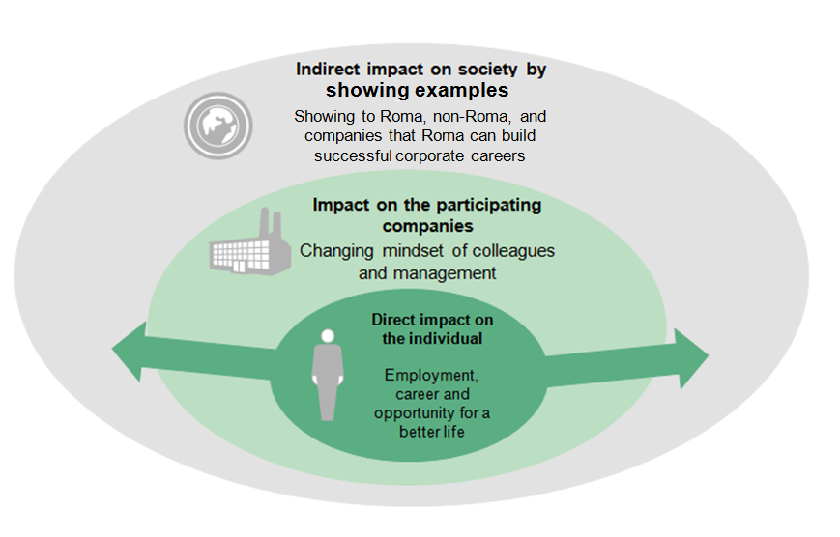

Program approach unites a group of diverse, credible stakeholders
After the vision was clearly defined, activities started in early 2013, Twenty major employers were interviewed with a view to the formation of a group of core corporate partners willing to take part in developing the details of the initiative (Budapest Bank, Raiffeisen Bank, Magyar Telekom, Videoton and E.ON). In the meanwhile, the program team researched existing public and civil initiatives, interviewed key experts in the area, and in general worked to develop a sophisticated understanding of the needs of the target group. By 2013 autumn, BCG joined forces with Autonomia Foundation, an NGO with recognized expertise in Roma integration. Autonomia Foundation became the key operating partner for the program, bringing expertise regarding the target group and the relevant civil and public landscape. A series of workshops followed with Autonomia and the core partners, to discuss needed program elements, plan timing and actions, set up the governance structure, and agree on the contribution required from all participating parties. With the operating model settled, and plans ready, the pilot launched at the beginning of 2014.
The story of Melinda
Melinda is from one of the poorest areas of the country, where she was raising her two children as a single mother, taking any job she could find. She was trained as a seamstress, but studying was important for her, so she graduated from high school and started a long-distance college course while being a working mother. Through Integrom, she got a chance to interview for the customer service team of a large telecommunication company, and she got the job! The position was in the capital, requiring her to move, but that didn't stop her. In only a few weeks time, she arranged new accommodation, found a school for her children, and was ready to start her new life.
Piloting the concept of a multistakeholder, voluntary collaboration is a key goal of Integrom – to find out how different perspectives can come together and work efficiently. The core of the program approach is to bring together organizations that are credible and trusted in their own field of work, and build on their strengths to deliver the best program possible. In the first years, we have learned a lot about how such a consortium can be managed and organized.

- How does Integrom connect applicants with opportunities?

The program consists of five key steps, adding value to both the Roma participants and the corporate partners, managed by BCG’s Integrom Team and Autonomia Foundation. Three recruitment and training periods run each year, involving a new group of 15-20 Roma each time.
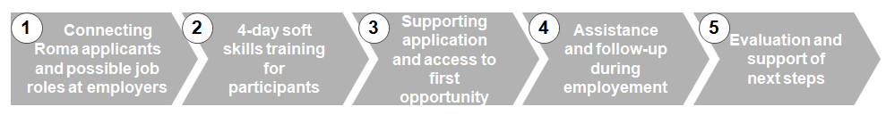

First, large employers are contacted to discuss willingness to participate, and then most relevant job roles for the program are identified through discussions. Ideal jobs do not require specific training or expertise, thus accessible to any applicant with secondary or higher education and the right motivation and skill set – such as call center, administration, back office, customer service positions.  When needs of several companies are collected, the focus areas for recruitment are defined (needed education, skills, geography). Based on this, the program team reaches out to various civil partners who can access and encourage Roma applicants across the country. Promotion through Facebook and network of former applicants is also used. | All applicants reached through the previous process are required to fill an application form and are briefly interviewed. Based on this, the best 15-20 people are invited to a 4-day training in Budapest (their transportation, accommodation and meals are covered by the program).  During the training, they learn about possible job opportunities, network with corporate representatives, improve self-confidence and communication skills through drama-pedagogy, practice CV writing, interviews, ACs, prepare for the most likely selection exercises, and create an individual plan for their next steps. | After the training, career goals of each participant are followed up and supported. The program team helps to finalize their CVs, answers questions about application processes, informs them about new openings, and provides financial and logistical support if needed (such as covering travel cost for interviews).  Corporate partners are notified when a participant applies to them. Most partners invite Integrom applicants at least for the first round of interviews, even if their CVs would not stand out among the other applicants. Integrom responsibles from the corporate side (usually HR or CSR) often look for job openings for a specific applicant and promote the program to hiring managers. | Participants are not left alone after a successful selection either. In most cases, the HR or CSR colleagues responsible for Integrom follow their progress closely, being a point of contact in case of any issues.  At the same time, the Integrom team is in touch both with the new hires and with the corporate contacts, regularly checking in to get feedback about their experience. | Successful participants are regularly invited to new rounds of trainings to share experiences with new applicants.  If their employment is discontinued for any reason, the program team helps to discuss learning points, update CVs, and look for new opportunities.  At the same time, corporate partners are invited to regular evaluation workshops, where they can share their experience with the applicants, and give ideas on how to improve the program.

Meanwhile, the program also provides support to corporate partners, who can benefit from the consulting experience of BCG in terms of adopting sensitive recruitment processes, communicating the program across the organization, engaging different stakeholders. They can also learn about CSR and diversity best practices from each other through facilitated workshops, and build a network with like-minded professionals.

- Which stakeholders contribute to making it happen?

One of the unique factors of the Integrom Program is the variety and size of stakeholders involved, mostly on a pro bono, voluntary basis. The program is exceptional in its ability to add value to all participants, to align the interests of many corporate and civil society organizations, but still keep operations running effectively without an overly bureaucratic structure. There are 3 types of stakeholder contributing to the program, coordinated by BCG and Autonomia Foundation.
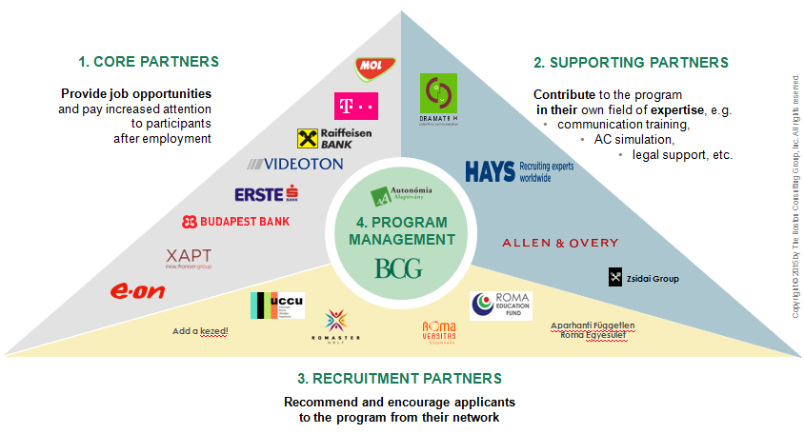

1. Core partners: Large employers who commit to the issue of Roma integration, and have a variety of relevant job roles available. Entering the program requires a commitment from senior management, the appointment of responsible person from the HR or CSR departments or CSR, and the opening up of recruitment processes to make them more accessible to Integrom participants. This usually means reviewing individual CVs, championing program participants within the company, and committing to giving a chance for a first interview. However, employers are in no way obliged to hire Integrom applicants only because they are Roma – the program strives for a mutually beneficial arrangement. As well as giving opportunities for Integrom applicants, core partners are also actively involved in shaping the program through regular workshops and feedback calls. Since starting with 4 core partners in 2013, the program has managed to attract many leading companies from a range of sectors, including telecommunications, banking, manufacturing, IT and utilities.

2. Supporting partners: To broaden involvement and keep costs low, several program activities are provided pro bono by professional companies. Dramatrix, a training company specializing in soft skills development through dramapedagogy facilitates a one and a half day session during the training, helping participants to build presence, increase self-confidence, and improve communication skills. Hays, a globally recognized recruiting firm, delivers a full day training and simulation on each step of a corporate recruitment process (from CV writing through interview simulation to AC games). Allen&Overy, a well-known law firm supports the program with legal advice in several aspects. And finally, Zsidai Group, a leading local fine dining chain hosts the networking dinner for corporate representatives and Roma participants during each training event. These companies are strongly committed to the issue and see it as a valuable experience for their participating volunteer trainers and colleagues. At the same time, they gain exposure to the network of core corporate partners as well.

3. Recruitment partners: In order to reach out to interested young Roma, a country-wide network of various civil organizations was established. Recruitment partners are Roma or pro-Roma NGOs with diverse profiles, working in local Roma communities or supporting Roma higher education students on a country-wide basis. They reach out directly to potential applicants, encourage and motivate them, complete the initial screening and support the participants locally throughout the program..

4. Program management: The Boston Consulting Group, as the main driver of the program the capacity of their consultants to design and improve program strategy, build and strengthen corporate relationships, manage corporate events and evaluation workshops, and guide companies in the best practice of sensitive recruitment. What BCG brings to the table is a well established professional brand, a wide network of leading companies, and strong capabilities for program design and management. Many BCG colleagues also volunteer for interview simulations, correcting CVs and supporting training logistics. In addition, BCG employs a half-time operative program manager, who coordinates the day-to-day issues of the program, manages supply and demand between jobs and applicants, and works out the details of partner involvement in training events and recruitment. At the same time, Autonomia Foundation brings the expertise in Roma integration, insights into the needs and problems of the Roma participants, the network of NGO partners. Their role is co-designing and developing the concept and methodology of the program, managing the recruitment and screening of the participants and providing the major part of the program finances. The two organizations work very closely together to connect the corporate and civil society elements of the initiative.

Each stakeholder plays a different, but crucial role
Roles and responsibilities were clarified through careful assessment of needs and interests, and a series of workshops bringing all partners together. It was vital that all partners had a say in where and how they would like to participate. The framework for cooperation is reviewed every year, and new participants are added continuously.

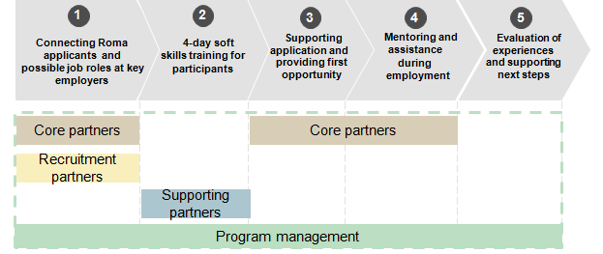
Key points of involvement for each stakeholder in the 5 steps of the program

- Governance and funding

Lack of legal formalities
Since 2014, the program has been operating as an informal platform without an official, independent legal form. This has made it easier for corporate partners to join and for the program team to manage the pilot phase. The contribution, roles and responsibilities of each partner organization are described in the Agreement of Cooperation - a "gentlemen's agreement" type of document without formal legal binding power – signed by each key stakeholder. Grants were applied for by Autonomia Foundation and financed managed for the program.
Key decisions were made by BCG consultants and the staff of Autonomia Foundation, with the involvement and input of other partners through regular workshops and reports. While this structure was a good fit for testing the concept and setting up a pilot quickly, scaling up the program will likely require setting up an independent organization and legal structure.

Very small operative team
During the pilot phase, the human resources required to manage the program were also kept to a minimum. A half-time program manager contracted by BCG takes care of most operative duties, supported by 3-4 months annual capacity of BCG consultants, overseen by a senior BCG Principal. Autonomia Foundation also provided a part-time program manager on a volunteer basis.

Financed by grants and donations
The pilot phase was almost completely financed by a grant from the Open Society Institute, with additional support from one of the participating companies, Hungarian Telekom. Due to the lack of paid staff, the budget of the pilot was small – less than 20 000 EUR was enough to finance core operations for more than a year.
The largest cost item is the participant-related costs such as transport, food and lodging at the training. In order to involve participants living in deep poverty, it is imperative that all program-related costs are covered for them. A much smaller part of the budget is allocated to cover operative costs of recruitment for Autonomia Foundation and the recruitment partners, and for printing and other communication expenses. At the moment, the effort and time of all stakeholders is fully pro bono, except the part-time program manager contracted and financed by BCG.
For the future, different business models are being considered that would help to scale up and set up a full time program team. The most likely alternative, apart from financing by grants, is to involve corporate partners in co-financing the initiative, asking for a moderate annual contribution from all core partners of the program.
The story of Gyula
Gyula lived in a small town near the Ukrainian border. Even though he had a Bachelor degree in andragogy from a regional college, he could only find employment in the framework of a public work scheme at the local library for a fraction of the minimum wage. Through Integrom, he learned about opportunities at a leading bank, which just opened a back office center in the area. After some preparation, Gyula completed all recruitment processes without problem, and found a job as a loan administrator with a stable salary and permanent contract – a job role he would never have considered before.
II. RESULTS AND INSIGHTS

1. What did we achieve?

Overall concept proven to work
At the start of the program, key performance indicators were set to measure success and to test whether the concept itself was feasible. Some of the most important questions the program had to answer were: can we match the applicants with the white-collar jobs available at the partner companies? Is it possible for companies to adjust recruitment processes so they are more flexible and inclusive? How will the applicants adjust to new working environment, will they be motivated to stay and will they be successful?
The last one and a half year has proven that the answer to all these questions is a clear yes. While there are still several points to improve, 9 applicants have been placed at various corporate partners, who are satisfied with their performance. This is a clear indication that a route to employment in the corporate white collar sector can and should be opened for Hungarian Roma.

Satisfied with ratio of participants placed, but several improvement points visible
- Number of applicants: 120
- Training participants: 57
- Number of corporate interviews attended by participants: 50
- Number of job offers: 15
- Number of participants employed: 9
- Number of participants employed after 6 months: 8
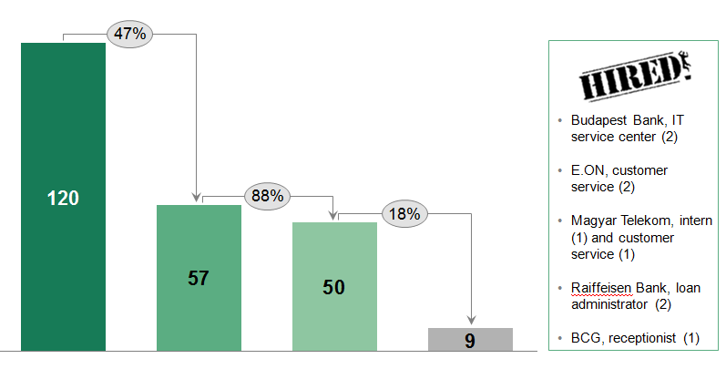
Key strengths are seen in the ratio of trained/interviewed – nearly all participants able to get an opportunity for an interview. Even if not all of them got a job, the chance to test themselves in a professional environment provided a valuable experience that could support their independent job search. The program team received several thank-you notes from participants who found jobs on their own, but still benefited from the training, CV review, and interview preparation. Another strength is the overall ratio of trained/placed – at 18%, we consider this a good result for a pilot Roma employment program. Participants have been placed in all kinds of industries from energy to banking to telecommunication, in diverse job roles. From the 9 placed people, only one person left the job so far, most of the applicants received good feedbacks from their managers and are performing well.
Major improvement opportunities lie in increasing the ratio of offers/hired applicants. Unfortunately, several applicants could not accept offers due to various issues, which we understood only through experience. First, mobility is a serious issue, not only because of cultural aspects, but mostly due to financial reasons. Salaries in some of the offered job roles are simply not high enough to start a new life, especially if one has a family as well. So in some cases, even though the job was a good fit, circumstances didn't allow the candidate to move. Second, the public work program run by the government proved to be a stronger competition than expected – as it offers opportunity to earn money for relatively low effort, without leaving their well-known environment, several candidates have backed off from corporate interviews to take more simple, temporary jobs in public employment. We've realized that the value of being employed by a stable, well-known company is not so obvious in these situations, and the program should communicate more about these issues upfront.
Finally, to bring the program to the next level, it will be crucial to increase the number of applicants. During the pilot, the program was kept on a smaller scale, allowing individual attention to each participant and each corporate partner. The next challenge is how to keep this approach while scaling up significantly at the same time.

Strong engagement from corporate and civil partners, effective cooperation
- Number of active core partners (at least 1 interview completed at the firm): 8
- Type of various job openings available through partners: 24
- Number of locations in Hungary with jobs offered: 5 larger cities
- Number of core partners with at least one participant hired: 4
- Number of supporting partners: 4
- Number of recruitment partner: 6

Doubling the number of active corporate partners is definitely a huge achievement, especially considering that those who joined at the beginning were already able to hire several applicants. Overall satisfaction from core partners shows that they see a return in the invested effort, and several stories of Integrom hires (such as Richard) confirm that Integrom applicants can fulfill expectations of the job roles in focus. A major realization was that companies often receive over-educated applicants for these jobs, which normally would make the CVs of Integrom applicants rank lower in overall comparison – this is why we ask for some flexibility in their recruitment process when participating in Integrom Program. However, most of these jobs (such as customer service, administration, IT support) do not actually need diplomas from the best universities, but need the right motivation, interest to learn, and a basic set of skills instead – which our applicants can also bring.
Cooperation with supporting partners has also been smooth and strong, the delivered services were of high quality, and participant feedback about the provided training were very positive. The network of recruitment partners also grew with time, enabling the program to recruit from 5 locations across Hungary, and reach out to a growing audience.
To even better fulfill corporate needs, the program will seek a better geographical match between candidates and jobs in the future, to off-set the extremely low mobility of participants.

2. What did we learn?

A unique initiative in the Hungarian Roma integration landscape, the Integrom Program has been a pioneer in creating a large and diverse pro bono coalition to address a controversial social issue. Of course, the program is far from perfect, with several areas where further development is possible. Nonetheless, the first year and a half has been an incredible learning journey for the program team and the key partners, generating many interesting insights.

With a good idea, it's possible to rally companies around a controversial issue
Initially, the program team was not sure how much commitment to expect from the corporate sector. Economic growth in Hungary has been sluggish since the financial crisis, with most companies cutting costs, restructuring, and laying off large number of people. Would they be interested to offer additional support to a discriminated minority, when they are already struggling?
Interestingly, during our discussions with partner companies, it became apparent that several companies do consider Roma employment an issue to stand behind, and have even tried various initiatives in the past, but often did not find the best way. Some described how they had started an initiative to integrate Roma into their organization, but ultimately failed to find applicants with a Roma background. Others suggested that they had to create “artificial” roles before they could find an appropriate job opening. Obviously these outcomes were disappointing, but the problem wasn't a lack of interest in Roma integration. Rather, what companies lacked was internal capacity to think through the requirements of integration into mainstream employment, access to potential candidates, and links to partners with good understanding of the position of the Roma in the labor market.
Since Integrom was designed with these issues in mind, it was possible to convince corporate partners to try again with a different method. The willingness of partners to participate in the program demonstrated that there was still a genuine willingness to tackle the disadvantages faced by the Roma.

New diversity tools should be integrated into companies' existing strategies
We've learned that most major companies (especially multinationals) have ambitious targets for workforce diversity, including minorities – even despite the economic recession, these targets are not forgotten. Several HR departments reported that they were under pressure from parent companies to deliver their diversity targets; and therefore welcomed all initiatives that could deliver these objectives. However, when it comes to Roma integration, most companies lacked well-structured initiatives and the capacity for proper implementation. For example, while integration of disabled employees is financially supported by the state, and companies are expected to have policies and programs for their support, such frameworks rarely exist for Roma employees.
As a start, it was crucial to understand existing diversity policies and CSR focus areas of the corporate partners, and figure out how Integrom can become a part of this ecosystem. This required the program to be adaptable to the specific corporate needs. For example, in one bank, Integrom was seen as a supporting recruitment channel to their newly opened back office center in the countryside, where they were struggling to find candidates in general. In another company, Integrom participants were partially channeled into their annual internship program, where they were looking for a more diverse group.

Teaming with credible, professional partners multiplies social impact
Since funding for social initiatives in Hungary is rather limited, and companies are regularly approached with requests to financially support various programs and issues, Integrom had to demonstrate how it can add value in a different way. The novelty of the program lies in asking for professional contribution instead of funding – an approach that is attractive to both corporate and civil partners, allowing the program to engage top organizations in their respective fields (employers, trainers, NGOs, experts).
The glue that holds the program together is a very deep understanding and strong alignment of the interests of all participating organizations and companies. For corporate partners, the real advantage of Integrom is that it enables companies to find a structured solution to the achievement of their CSR objectives, in which BCG’s reputation as a credible partner has proved critical. Roma and pro-Roma NGOs are motivated to participate on a pro-bono basis as the program provides a very important chance for the young Roma who are their most important target groups that they have been supporting for e.g. during their studies. Finally, trainers and other supporting companies are incentivized by being part of a "club" of prestigious companies, leading to possible future business opportunities – and also by taking part in an interesting professional challenge to support an important social issue.

Personal motivation of participating individuals is a strong driving force
Apart from the above described organizational motivation of participating stakeholders, we learned that the impact of individual commitment of participating colleagues should not be underestimated either. Experience from the pilot has shown that collaboration works much better if there are individuals personally committed to the issue from each side.
The CSR and HR colleagues responsible for Integrom at the corporate partners have gone way beyond what would be formally required from them – spending evenings talking to applicants, giving ideas to the program team, putting effort into convincing their colleagues about Integrom, and even going as far as transporting candidates with their own car to make sure they make it to the interviews.
The trainings are also a great example of impact achieved by motivated individuals. Trainer colleagues from Dramatrix and Hays (the two participating training companies) spend their weekend volunteering because they care about the issue and enjoy helping out personally. Every training, up to 10 BCG colleagues also spend a Saturday or Sunday simulating interviews, giving feedback to CVs, or delivering an Excel training – purely out of personal motivation.
And last but not the least, the overwhelming positive attitude and voluntary effort from colleagues of Roma and pro-Roma NGOs makes it possible to make the program attractive to potential applicants.

3. Challenges in reaching the next level

After the successful pilot phase, and with an overall concept that is proven to work, it is time to start working on scaling up the program. This will pose several challenges, which are currently being discussed by the project team.

Institutionalizing the program for everyone involved
During the pilot phase, the current arrangements worked very well. Establishing the program as a flexible, low bureaucracy, volunteer-based coalition made it easy for anyone to join without making long-term commitments. However, in order to scale up significantly, a more solid framework of cooperation will be needed. This is likely to include setting up an independent legal organization (a foundation or association), with full time staff. Participating companies might need to sign formal agreements, while core partners could sit on a board to oversee operations.

Business model change needed for more sustainable funding
The pilot phase has been incredibly low-cost; however, grants and occasional donations are not sustainable enough. Operational costs will dramatically increase with the employment of full-time staff, and training costs will also grow. Unfortunately, the funding environment for the civil sector is neither strong nor stable in Hungary. In order to ensure sustainability, the ideal business model will likely require financial contributions from participating companies – however, this increases administration and makes the program more formal and harder to sell.
At the same time, providing more intensive consulting to companies about CSR best practices, diversity policies, sensitive recruitment processes could be an extra added value to corporate partners, motivating them to financially contribute.

Stronger outreach and value proposition to potential participants
The current model of reaching Roma through direct connections worked well for the start-up phase; however, we can already see that the application numbers are stagnating. If we want significant growth, we need a well targeted, more open communication strategy on both social and traditional media.
At the same time, to make the program attractive for a larger group, improving the professional content of the training aspect has to be high on the agenda. Developing a more flexible, modular training structure would enable applicants to chose courses based on their individual needs. Ideally, the program should offer more hard-skills training as well, especially in the field of languages and computer skills (skills often stopping participants from getting the job they want). Giving participants options to try themselves as volunteers or interns first before applying to jobs would also increase their employability. Finally, adding a personal coaching element to the program would make sure that each applicant can maximize the benefits of the program, and make good decisions about their career.

The story of Renáta
Renata had a college degree as a cultural manager, but was unable to find a job in her field. Before Integrom, she was working as a receptionist in a large office building, without any career prospects and fairly simple daily tasks. The Integrom training allowed her to practice communication and interview skills she hasn't used for a long time, and connected her with new opportunities. Later on, she was selected for a receptionist position at BCG, but this time with much more diverse scope of responsibilities, better compensation and chance for further career steps.

III. TRANSFERRING THE CONCEPT TO OTHER REALITIES

1. What principles are at the core of the program?

The Integrom Program was created for a specific target group, for the Hungarian context. However, we believe that the basic elements, principles and insights from the program can be described in a more general way, and can be used as a blueprint for designing similar initiatives in other contexts. In the next pages, key elements of such a blueprint will be elaborated, with recommendations on prerequisites, main steps, and possible challenges of implementation.

Basic principles of the "Integrom Method" can be followed in different realities
- Disadvantaged target group: Intervention targeted at a disadvantaged group, who face serious challenges in the labor market which cannot be solved by market mechanisms only (e.g. other minorities, migrants, people with criminal record, people with disabilities, unemployed women etc.).
- Driven by corporate sector need: Intervention involves a group of major employers in the country, who are both committed to the issue and have a business reason to hire from the target group (e.g. not including women in the workforce limiting growth in many Arab countries), and are willing to make recruitment more flexible and inclusive
- Coalition of trusted partners: The program brings together professionals experienced in all key aspects of the selected social issue, each credible and well known to their own target group. This ,,trust capital" ensures engagement from corporate sector and interest from the target group
- Bridge building: Enabling the target group to get an opportunity for employment through trainings, network, and connections, but not guaranteeing employment through hard quotas.
- Voluntary cooperation: Most involved parties invest their time and effort in the program for free, contributing in their own specific way, taking part in shaping the program
- Non-political, non-governmental management: An independent private sector-civil society initiative, run by an independent, professional organization

2. The five steps of Integrom can serve as a blueprint for program design

The five specific steps seen in Integrom can be described as a more general blueprint for implementation in a different context. Below is an overview of what elements could be implemented for each step, including recommendations on key factors for success.
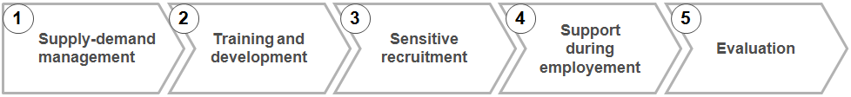

1. Supply-demand management
Key elements: Identify possible job opportunities which are in scope of the program, assess demand from corporate side, and collect all needs. Build a network of relevant organizations to access members of the target group who could be a good match for corporate needs. Communicate needs and expectations from both sides, integrate all inputs.
Success factors:
  - A trusted partner organization who can reach out to program participants credibly
  - Clear focus defined for what kind of jobs are in or out of scope – being able to say no if a corporate profile does not fit
  - Geographical coverage taken into consideration and matched carefully (e.g. if the target group lives in rural areas, companies in the capital won't help)

2. Training and development
Key elements: Assess the skill gap between the target group and the job roles. Design a training curriculum to address (part of) this. Build a network of training organizations and volunteers for delivering the sessions.
Success factors:
- Clear definition of what can and cannot be solved by the type of training that is realistic to execute from available budget/capacity
- If the skills gap is too wide, redefining target group or job types should be considered

3. Sensitive recruitment
Key elements: Decide what should be the level of affirmative action that the program can/should provide for the participants (depending on how such programs are viewed in society, how open are the companies, and also on legal background). Clarify how this is executed with each key partner. Set up a system to manage information about applicants and jobs, and track results.
Success factors:
  - Consulting with participants of the target group can help to understand what would make them comfortable
  - Finding the right balance between the amount of support that make a real difference, and the amount of support which is too much and can generate resentment among other colleagues
  - Understanding if there is a fit with HR strategy and overall corporate situation – in times of restructuring and lay-off, the program might face more challenges

4. Support during employment
Key elements: Define what support should be provided for applicants after they have been recruited, clarify what should the corporate partner and what should the program team provide
Success factors:
  - Ensure that there is enough capacity for individual attention to every successful participant
  - Emergency situations might occur – the program team should have a plan how to react in case of logistical, financial, or integration issues of participants

5. Evaluation
- Key elements: Define regular evaluations methods such as workshops and annual reports, analyze the impact of the program regularly, evaluate the experience of each individual who was hired
- Success factor:
  - Keep in touch with all alumni, motivate them to be connected to the program
  - Engage all partners in giving feedback and defining the direction of the program – this will increase their ownership even without a formal commitment

3. Partners in the four key stakeholder groups can be customized to local reality

Within the 4 major stakeholder groups, there is a lot of room to customize who gets involved in the program based on local realities and the needs of the target group. However, there are some best practices to make sure all of them are engaged, committed, and motivated to participate.
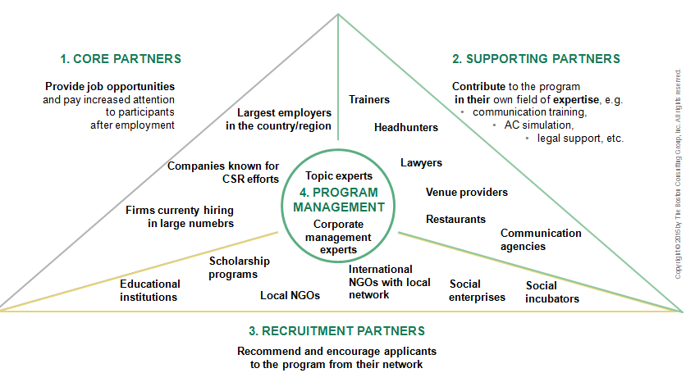
1. Core partners
- Getting approval and commitment from the top leadership first will make operative discussions much faster and effective
- The first group of core partners are crucial for success and for motivating further joiners – start with companies you know and can easily access
- Provide regular feedback on program progress, results, challenges – even if it does not directly concern the specific company
- Create opportunities for corporate managers to personally engage with the target group, such as dinner with applicants, workshops, gatherings
- Find the right person in the company – usually an HR manager/director responsible for the most relevant job roles, or a CSR/equal chance manager with enough leverage to drive change

2. Engaging supporting partners
- Training partners are the most crucial and can take a huge workload off the program management. Winning credible, professional training firms for the program helps to build a strong brand and attract applicants
- Supporting partners usually benefit from exposure to core partners – make sure to showcase them in marketing materials and involve them in corporate events

3. Engaging recruitment partners
- Find established local organizations in relevant locations who are able to reach out to the target group on a local/national level. These must be already established, with a strong understanding of the target group, trusted by the potential applicants
- Look for several, different organizations from the same geographical area to be able to diversify the network you tap into
- Keep recruitment partners motivated by continuous feedback about program progress, especially in case of applicants recommended by them

4. Program management

- Building the right partnerships is a deal-breaker for program success
- Winning the trust of the corporate sector requires a managing organization which speaks the language of large companies, has a strong brand, and is experienced in program management
- On the other hand, managing the network of various organizations and understanding the target population requires experience in a different area, that's why working with a partner specialized in the issue can be a huge the advantage

4. Five different phases recommended to launch and implement the program

Based on the example of Integrom, setting up a similar program pilot from idea to first group of trained participants can be done in about a year. However, getting the program right might need some learning through trial and error – it may be best to plan over a 3 year period until the most effective operating and business models are found and the program is ready to be scaled-up.

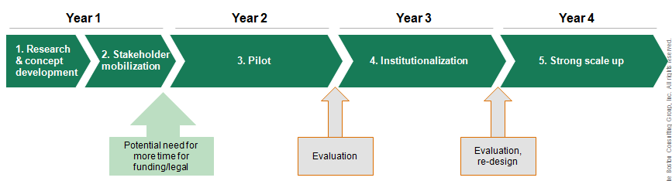

The first year is crucial to understand the issues and engage stakeholders
Ideally, half year should be allocated for research, expert interviews, segmenting the target group, and interviewing potential partners to get a sense of needs and interests. The next half year is best spent with a series of workshops involving key partners (core, civil and supporting partners alike) to clarify roles, responsibilities, agree on operating details, and address all major concerns. Based on this, a detailed program plan with goals can be prepared by the end of the first year. Depending on the chosen legal and financial model, more time might be required to acquire funding and arrange administrative necessities. However, if the program follows the low-cost, low-HR model of the Integrom pilot, the first round of recruitment can already start.

Institutionalizing and scaling up will take another 2-3 years
The second year can be the actual pilot, organizing 3-4 rounds of recruitment and training, focusing on the most accessible job roles and most cooperative partners. During this phase, it's recommended to meet regularly with core partners and collect immediate feedback, so mistakes can be corrected as the program unfolds. If major milestones are met during the year (e.g. at least 1 person employed at each major partner), the program is ready to evolve towards a more institutionalized form in year three - with full time employees, independent legal structure and other adjustments needed for stable operations. If the results are positive, year four can be dedicated to implementing an operating model that enables a much bigger scale. This might require major changes in key activities (e.g. launching a large-scale media campaign, changing business model), in which case partners should be informed and asked for input.

5. Risks of implementation to be assessed early on

We believe the Integrom method is applicable to many different contexts due to being low cost, voluntary, and building on the common interests of everyone involved. However, there are potential risks associated with implementation, which should be assessed in advance.
First of all, economic situation of the country can hugely influence the success of such a program. In times of serious recession, or high unemployment, companies will be much less willing to support employment of a specific disadvantaged group (and it would likely generate more negative reactions from other employees).
Second, political context of the issue needs to be well understood. Even if the program is non-political, there are several points where a government that is ignorant or hostile towards the issue can be a threat to success (for example when trying to cooperate with state-run employment centers). Also, companies might be less willing to support the topic if they fear repercussions from the government.
Finally, strong cultural resistance towards the chosen target group would require the program to focus more on awareness raising and sensitivity training at the employers - something Integrom did not have to handle directly at the current partners because they were all strongly committed to equality in the workplace.
To detect and overcome these problems, we recommend assessing such risks during the research and the stakeholder mobilization phase, so that a decision can be taken whether the program concept needs to be adjusted to mitigate them before the pilot starts.
IV. MID-TERM VISION FOR THE INITIATIVE
The story of Dávid
David graduated from a technical high school, and started studying electric engineering at a Budapest university. He was looking for part-time work to finance studies, but was secretly hoping to find a position related to his hobby, telecommunication technology. Integrom helped him to brush up his CV and interview skills, and to try himself at several companies. The first few interviews didn't work out, but luckily, the program team came across an internship at a leading telecommunication firm, and recommended Dávid. He is now employed in his "dream job", with good prospects for a permanent contract when his internship ends.

What's next for Integrom?
As discussed in this paper, Integrom is a new pilot program, just about to enter the scale-up phase. However, the pilot has proven that the concept works, and that there is strong support behind the idea from both the corporate sector, the civil society organizations and from the target group. This gives us confidence that there is both space and need to grow. In the mid-term (3-5 years), our vision for the program is to scale up significantly, institutionalize, and start becoming a well-known career route for young Roma and a ,,must club" for companies.
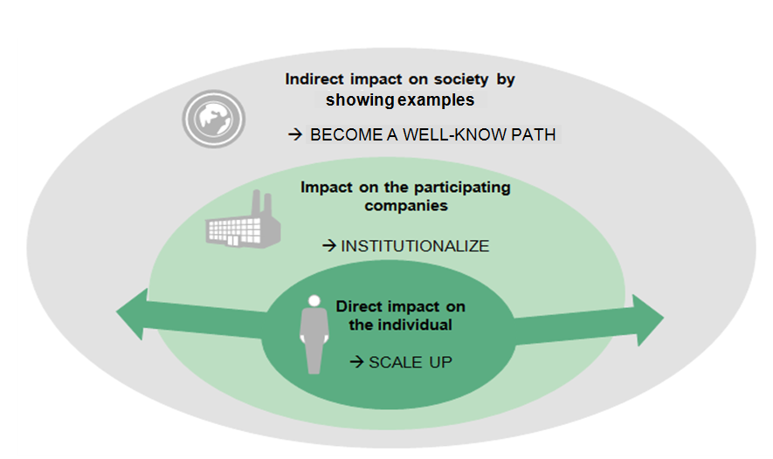
To increase our direct impact on individuals, we imagine scaling up to at least 40 people placed per year, operating with several hundreds of applicants, a strong alumni network, and many success stories. Ideally, Integrom would become such a well-know program amongst the Roma, that we could attract applicants without huge communication campaigns. To accommodate the scale, Integrom will have to change to a more modular training structure, delivered by a larger and more diverse network of training partners.

Regarding the impact on participating companies, we expect the program to become part of their "business as usual" operations. Screening and hiring Roma applicants will be integrated in HR strategies, not only as CSR activity, but as a great recruitment channel. Mentoring Integrom participants could become a requirement for rising managers, as seen in the German JobLinge project supporting unemployed youth in a similar way. Corporate partners will start seeing program participation as an investment in diversity, willing to contribute financially to the sustainability of the initiative. Participation will be more standardized; new partners will be able to implement sensitive recruitment practices quickly with the help of guidebooks and best practices.

In the further future, we hope to see mindsets beginning to shift in Hungarian society bit by bit. By creating more and more examples every year, access to corporate careers will start to become a well-known option both for Roma job seekers and for companies. Due to the increased number of placed participants, thousands of people will experience working with talented Roma colleagues, changing their view on the Roma community. In high schools and universities, all Roma will be informed about the program and will look forward to joining it as a natural next step. Finally, involvement of companies will expand beyond single firms - whole industries might line up behind the initiative, and companies will further recommend the program to foreign subsidiaries.
The journey continues

Integrom is still at the beginning of the ambitious journey to become a game-changing program for the Hungarian Roma population. However, what we have seen in the last two years is more than encouraging: strong interest and commitment from leading companies, great cooperation from civil society, and most importantly, many positive examples of motivated, hard working, talented candidates.

We have seen a single mother of two moving from an impoverished rural area to the capital with two children, and starting a new life working at a leading telecommunication company.

We have seen training participants too shy to speak on the first day take leadership role during assessment center exercises only two days later.

We have seen an HR director of a large company personally welcoming candidates at the bus station, and driving them to their interview appointments.

We have seen the happiness and surprise of a freshly hired participant when he received a corporate mobile phone on his first day.

We have seen Richard investing hours of overtime work every day, in order to learn the skills needed for his desired promotion.

And we hope to see more if this – maybe not only in Hungary, but all over the world.

CONTRIBUTORS

LIST OF REFERENCES

http://www.oecd.org/cfe/leed/Tackling%20Long_Term%20unemployment_%20WP_covers.pdf
http://ec.europa.eu/justice/discrimination/files/roma_country_factsheets_2014/hungary_en.pdf
http://europa.eu/rapid/press-release_MEMO-14-249_en.htm
Fazekas K., Benczúr P. and Telegdy Á. (eds) (2013), The Hungarian Labour Market 2013, Budapest: Centre for Economic and Regional Studies, HAS & National Employment Non-Profit Public Company Ltd. 335 p
http://europeandcis.undp.org/data/show/D69F01FE-F203-1EE9-B45121B12A557E1B FRA-UNDP-WB 2012
http://fra.europa.eu/sites/default/files/fra-2014_roma-survey_education_tk0113748enc.pdf
http://romagov.kormany.hu/download/9/e3/20000/Strat%C3%A9gia_1sz_mell%C3%A9klet_Helyzetelemz%C3%A9s.pdf
http://europa.eu/rapid/press-release_MEMO-14-249_en.htm
http://www.tarki.hu/hu/news/2013/kitekint/20131211_szegenyseg.pdf
http://romagov.kormany.hu/download/9/e3/20000/Strat%C3%A9gia_1sz_mell%C3%A9klet_Helyzetelemz%C3%A9s.pdf
http://europeandcis.undp.org/data/show/D69F01FE-F203-1EE9-B45121B12A557E1B
http://fra.europa.eu/sites/default/files/fra-2014_roma-survey_education_tk0113748enc.pdf
Babusik. F (2001), "Romákat foglalkoztató vállalkozások kutatása".
http://ec.europa.eu/justice/discrimination/files/country_assessment_2014/hungary_en.pdf
http://www.modernizacio.hu/download/454/file/tamop541_iv_921_roma_a5.pdf
http://Autonómia.hu/en
http://www.joblinge.de/was_ist_joblinge/daten_und_fakten.html http://www.joblinge.de/was_ist_joblinge/daten_und_fakten.html

